Programming Assignment #5
(for Ch 8 and ch16)

Problem Description

Create a Date class with the following capabilities:
- Output the date in multiple formats such as
MM/DD/YYYY
June 14, 1992

- Use overloaded constructors to create Date objects initialized with dates of the formats in part a).

You should only have 3 member data: integer month, integer day, and integer year. Also, you should have at least 2 constructors and 2 methods in your Date.java.

public Date ( int mm, int dd, int yy )
{ // check mm, dd, and yy and save them into month, day, and year member data.
…
}

public Date ( String mstr, int dd, int yy )
{ // check and convert mstr, dd, and yy and save them
// into month, day, and year member data.
…
}

public String toString ( )
{ // return a string that contains MM/DD/YYYY
…
}

public String toFullDate ( )
{ // return a string that contains long date such as
// June 24, 2002
…
}

[Hint: You can compare Strings using method equals or equalsIgnoreCase. Suppose you have two String references s1 and s2, if those Strings are equal, s1.equals( s2 ) returns true; otherwise, it returns false. Method equalsIgnoreCase compares two Strings with no case-sensitive.]

Note: This problem is similar to the question 8.14 on page 356.

Sample Run

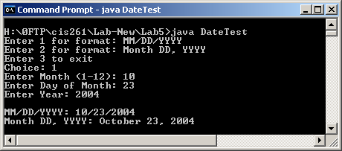 | 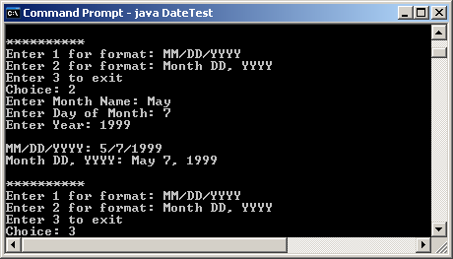

Problem Requirement
a) You must use a separate file for the Date class.
b) You must use a separate file for the Testing program.
c) The Date class should contain only 3 member data: month, day, and year. They are all integer data.
d) Your program should run correctly with the same inputs and outputs as given in the sample run.
e) Your program must check for invalid inputs and also the leap year. Please see page 329 for reference.
f) You may download the .class file from here to test run.

Bonus Program
a) Make duplicate copy of DateTest.java. Name the new copy as DateTest2.java.
b) Revise DateTest2.java so that JApplet is used. See chapter 23 for reference.

